**Data Science step1**

Introduction to data and its types

Continuous data and discrete data

Nominal and ordinal data

Data Processing: -

Reading data, handling missing data, categorical data, splitting data in training and testing, Normalize data

Web Scrapping:

What is Web Scrapping, Web Scrapping processing, search elements in different ways, how to use developers tools in browser

Exploratory data analysis: -

EDA of pima Indian diabetes dataset, visualize it,

Data Transformation and scaling data: -

Rescal data , standardize data, normalize data and binarize data

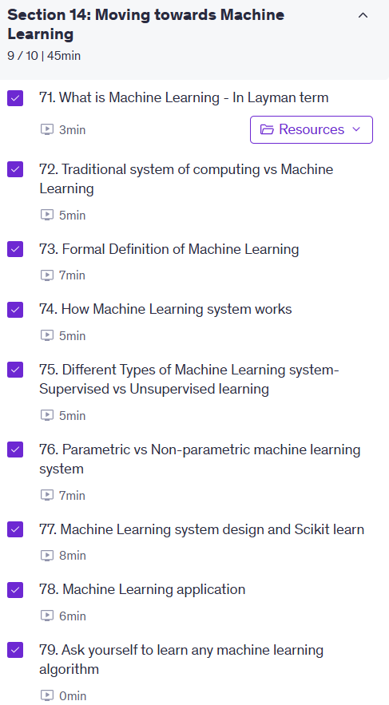

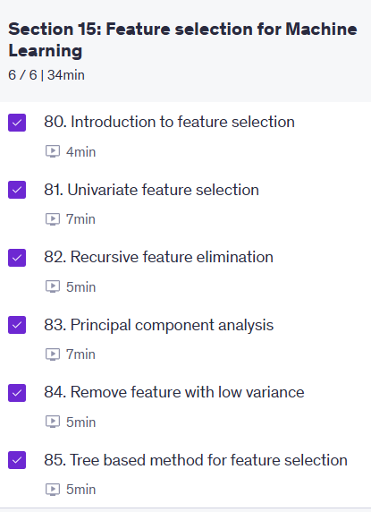

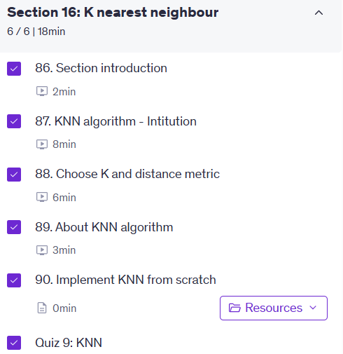

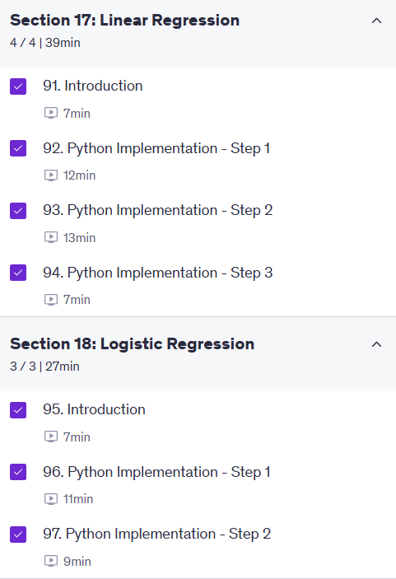



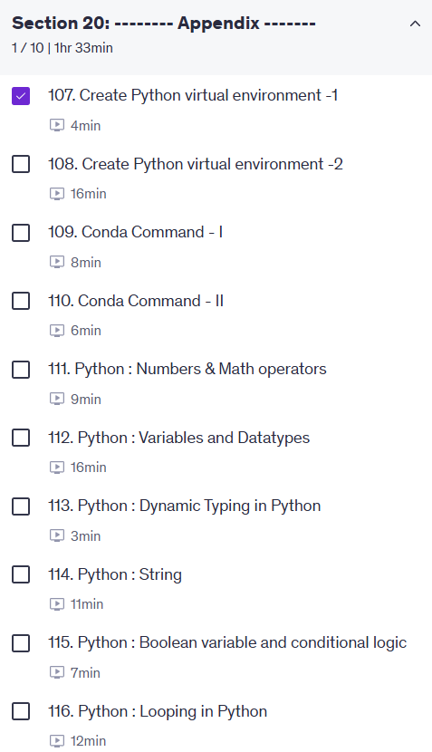

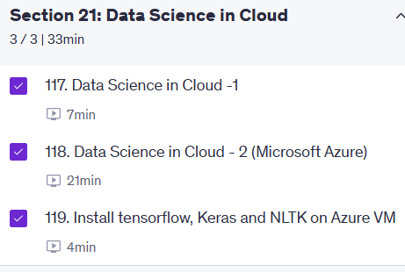

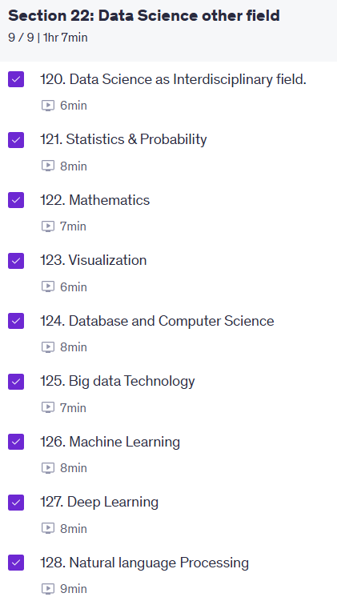





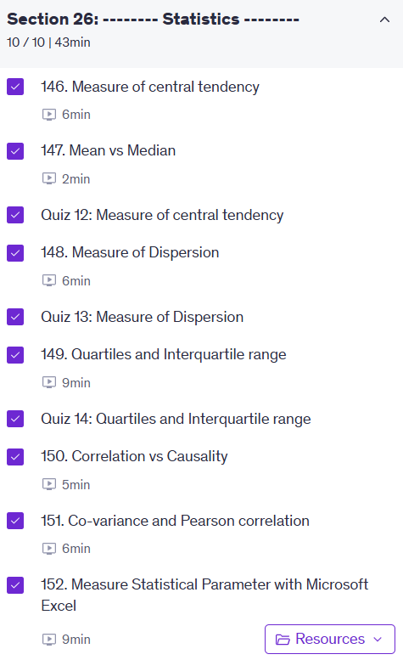

For predicting categorical output which machine learning types of algorithm used

Top of Form

In which type of machine learning technique output label has been given

* **supervised learning**
* **Unsupervised learning**

Bottom of Form

Top of Form

Predicting whether image contains cat dog or human face.

This type of problem can be solved with which type of machine learning system

* **Regression**
* **classification**

Bottom of Form

Top of Form

Predicting probability of given email is spam.

This type of problem can be solved with which type of machine learning system

* **Regression**
* **Classification**
* **Clustering**
* **Reinforcement learning**

Bottom of Form

Which system will you preferred to solve given problem below.

1. Predicting Cat or Dog

2. Find number is odd or even

3. Find shortest route between two node

4. Predict tomorrow stock price.

TS - Traditional system

ML - Machine Learning

Top of Form

Which type of machine learning I did not discuss.

* **Supervised learning**
* **Reinforcement learning**
* **Classification**
* **Unsupervised learning**
* **Regression**

Bottom of Form

<https://www.udemy.com/course/machine-learning-course-with-python/learn/lecture/16722374?start=0#overview>

# what is data preprocessing uses in Machine learning

# Data preprocessing is a crucial step in the machine learning pipeline. It involves transforming raw data into a format that is suitable for modeling. This process can include various tasks such as cleaning the data, handling missing values, encoding categorical variables, scaling numerical features, and splitting the dataset into training and testing sets. Proper data preprocessing can significantly improve the performance of machine learning models by ensuring that the data is in a consistent and usable format.

# Data preprocessing is important because:

# 1. **Data Quality**: Raw data often contains errors, inconsistencies, and missing values. Preprocessing helps to clean the data and improve its quality.

# 2. **Model Performance**: Many machine learning algorithms assume that the data is in a certain format. Preprocessing ensures that the data meets these assumptions, which can lead to better model performance.

# 3. **Feature Engineering**: Preprocessing allows for the creation of new features that can enhance the model's predictive power.

# 4. **Scalability**: Preprocessing can help to scale the data, making it easier for algorithms to converge and learn from the data.

# 5. **Interpretability**: Properly preprocessed data can make it easier to interpret the results of the model and understand the relationships between features and the target variable.

# 6. **Efficiency**: Preprocessing can reduce the dimensionality of the data, making it more efficient to train models and reducing computational costs.

# 7. **Generalization**: Preprocessing can help to reduce overfitting by ensuring that the model is trained on a representative sample of the data.

# 8. **Data Integration**: Preprocessing can help to combine data from different sources, ensuring that the data is consistent and usable for modeling.

# 9. **Data Transformation**: Preprocessing can help to transform the data into a format that is more suitable for modeling, such as normalizing or standardizing the data.

# 10. **Data Visualization**: Preprocessing can help to prepare the data for visualization, making it easier to understand the relationships between features and the target variable.

# 11. **Data Exploration**: Preprocessing can help to prepare the data for exploration, making it easier to identify patterns and trends in the data.

# 12. **Data Validation**: Preprocessing can help to validate the data, ensuring that it is accurate and reliable for modeling.

# 13. **Data Sampling**: Preprocessing can help to sample the data, ensuring that the data is representative of the population and reducing bias in the model.

# 14. **Data Augmentation**: Preprocessing can help to augment the data, creating new samples from existing data to improve model performance.

# 15. **Data Normalization**: Preprocessing can help to normalize the data, ensuring that the data is on a similar scale and reducing the impact of outliers.

# 16. **Data Encoding**: Preprocessing can help to encode categorical variables, ensuring that the data is in a format that is suitable for modeling.

# 17. **Data Binning**: Preprocessing can help to bin continuous variables, creating categorical variables that can improve model performance.

# 18. **Data Discretization**: Preprocessing can help to discretize continuous variables, creating categorical variables that can improve model performance.

# 19. **Data Smoothing**: Preprocessing can help to smooth the data, reducing noise and improving model performance.

# 20. **Data Transformation**: Preprocessing can help to transform the data, ensuring that it is in a format that is suitable for modeling.

# 21. **Data Reduction**: Preprocessing can help to reduce the dimensionality of the data, making it easier to train models and reducing computational costs.

# 22. **Data Selection**: Preprocessing can help to select the most important features, improving model performance and reducing overfitting.

# 23. **Data Cleaning**: Preprocessing can help to clean the data, removing errors and inconsistencies that can impact model performance.

# 24. **Data Transformation**: Preprocessing can help to transform the data, ensuring that it is in a format that is suitable for modeling.

# 25. **Data Integration**: Preprocessing can help to integrate data from different sources, ensuring that the data is consistent and usable for modeling.

# use of StandardScaler library explain in details

# StandardScaler is a preprocessing technique in machine learning that standardizes features by removing the mean and scaling to unit variance.

# It is commonly used when the features have different units or scales, as it helps to normalize the data and improve the performance of machine

# learning algorithms. The formula for standardization is: z = (x - mean) / std, where x is the original value, mean is the average of the feature,

#  and std is the standard deviation. StandardScaler is particularly useful for algorithms that are sensitive to the scale of the data, such as Support

#  Vector Machines (SVM) and k-Nearest Neighbors (k-NN). By standardizing the features, we can ensure that they contribute equally to the distance

# calculations and improve the convergence of optimization algorithms.

# use of MinMaxScaler library explain in details

# MinMaxScaler is a preprocessing technique in machine learning that scales features to a specified range, typically between 0 and 1. It is useful when

# the features have different units or scales, as it helps to normalize the data and improve the performance of machine learning algorithms. The formula

#  for MinMax scaling is: X_scaled = (X - X_min) / (X_max - X_min), where X is the original value, X_min is the minimum value of the feature, and X_max

# is the maximum value of the feature. MinMaxScaler is particularly useful for algorithms that are sensitive to the scale of the data, such as neural

# networks and k-Nearest Neighbors (k-NN). By scaling the features to a common range, we can ensure that they contribute equally to the distance calculations

#  and improve the convergence of optimization algorithms.

# use of OneHotEncoder library explain in details

# OneHotEncoder is a preprocessing technique in machine learning that converts categorical variables into a format that can be provided to machine learning algorithms.

# It creates binary columns for each category in the categorical variable, where each column represents a category and contains a 1 if the category is present and 0 otherwise.

# This is useful for algorithms that cannot work with categorical data directly, as they require numerical input. OneHotEncoder is commonly used in conjunction with other preprocessing techniques, such as StandardScaler or MinMaxScaler, to ensure that all features are in a suitable format for modeling. By using OneHotEncoder, we can effectively represent categorical variables and improve the performance of machine learning models.

# OneHotEncoder is particularly useful for algorithms such as linear regression, logistic regression, and decision trees, which require numerical input.

# It is also useful for algorithms that are sensitive to the scale of the data, such as Support Vector Machines (SVM) and k-Nearest Neighbors (k-NN). By converting categorical variables into a numerical format, we can ensure that they contribute equally to the distance calculations and improve the convergence of optimization algorithms.

# OneHotEncoder can also help to reduce the dimensionality of the data by creating binary columns for each category, which can improve model performance and reduce overfitting. Additionally, OneHotEncoder can help to improve the interpretability of the model by providing a clear representation of the categorical variables and their relationships with the target variable. Overall, OneHotEncoder is a powerful tool for preprocessing categorical data and improving the performance of machine learning models.

# use of LabelEncoder library explain in details.

# use of LabelEncoder library explain in details

# LabelEncoder is a preprocessing technique in machine learning that converts categorical variables into numerical format by assigning a unique integer to each category. It is useful for algorithms that require numerical input, as it allows us to represent categorical variables in a way that can be easily processed by machine learning algorithms. LabelEncoder is commonly used for ordinal categorical variables, where the categories have a natural order, such as "low", "medium", and "high". By using LabelEncoder, we can effectively represent categorical variables and improve the performance of machine learning models.

# LabelEncoder is particularly useful for algorithms such as decision trees, random forests, and gradient boosting, which can handle categorical variables directly.

#  However, it is important to note that LabelEncoder should not be used for nominal categorical variables, where the categories do not have a natural order, as it can introduce unintended relationships between the categories. In such cases, OneHotEncoder or other encoding techniques should be used instead. Overall, LabelEncoder is a powerful tool for preprocessing categorical data and improving the performance of machine learning models.

# It is also useful for algorithms that are sensitive to the scale of the data, such as Support Vector Machines (SVM) and k-Nearest Neighbors (k-NN). By converting categorical variables into a numerical format, we can ensure that they contribute equally to the distance calculations and improve the convergence of optimization algorithms.

# LabelEncoder can also help to reduce the dimensionality of the data by creating binary columns for each category, which can improve model performance and reduce overfitting. Additionally, LabelEncoder can help to improve the interpretability of the model by providing a clear representation of the categorical variables and their relationships with the target variable. Overall, LabelEncoder is a powerful tool for preprocessing categorical data and improving the performance of machine learning models.

# use of train_test_split library explain in details

# train_test_split is a function in the scikit-learn library that is used to split a dataset into training and testing sets. It is an essential step in the machine learning pipeline, as it allows us to evaluate the performance of our model on unseen data. The function takes in the features (X) and target variable (y) as input and splits them into training and testing sets based on a specified test size or proportion. By default, it randomly shuffles the data before splitting, ensuring that the training and testing sets are representative of the overall dataset. The train_test_split function also allows for stratified sampling, which ensures that the distribution of classes in the target variable is preserved in both the training and testing sets. This is particularly important for imbalanced datasets, where one class may be underrepresented. Overall, train_test_split is a powerful tool for preparing data for machine learning models and ensuring that they are evaluated on a representative sample of the data.

# use of simpleImputer library explain in details

# SimpleImputer is a preprocessing technique in machine learning that is used to handle missing values in a dataset. It provides a simple and efficient way to impute missing values by replacing them with a specified value, such as the mean, median, or mode of the feature. SimpleImputer is particularly useful when dealing with datasets that have missing values, as it allows us to fill in the gaps and ensure that the data is complete and usable for modeling. By using SimpleImputer, we can effectively handle missing values and improve the performance of machine learning models.

# SimpleImputer is commonly used in conjunction with other preprocessing techniques, such as StandardScaler or MinMaxScaler, to ensure that all features are in a suitable format for modeling. It can also be used in combination with other imputation techniques, such as KNN imputation or regression imputation, to provide a more robust solution for handling missing values. Overall, SimpleImputer is a powerful tool for preprocessing data and improving the performance of machine learning models.

# It is also useful for algorithms that are sensitive to the scale of the data, such as Support Vector Machines (SVM) and k-Nearest Neighbors (k-NN). By imputing missing values, we can ensure that all features are complete and usable for modeling, which can improve the convergence of optimization algorithms and reduce overfitting. SimpleImputer can also help to improve the interpretability of the model by providing a clear representation of the missing values and their relationships with the target variable. Overall, SimpleImputer is a powerful tool for preprocessing data and improving the performance of machine learning models.

# use of pipeline library explain in details